**Data Control Language**

**Aim:**

To study about “Data Control Language” commands in Mysql.

**Uses of DCL :**

* It is used inorder to control various operations of the database objects.
* Two commands are supported by this language.
* Grant
* Revoke
* **Grant**: This command is used to grant permission on database objects from one user to another user.
* **Revoke**: This command is used to cancel the given permission

MySQL server provides multiple types of privileges to a new user account. Some of the most commonly used privileges are given below:

1. **ALL PRIVILEGES:** It permits all privileges to a new user account.
2. **CREATE:** It enables the user account to create databases and tables.
3. **DROP:** It enables the user account to drop databases and tables.
4. **DELETE:** It enables the user account to delete rows from a specific table.
5. **INSERT:** It enables the user account to insert rows into a specific table.
6. **SELECT:** It enables the user account to read a database.
7. **UPDATE:** It enables the user account to update table rows.

**Syntax:**

Grant <Permission List> on <table name> to <Users List>

Eg: Grant select, insert on students to kero;

**GRANT** ALL **PRIVILEGES** **ON** table name **TO** username;

Sometimes, you want to **flush** all the privileges of a user account for changes occurs immediately, type the following command.

FLUSH **PRIVILEGES**;

If you want to see the existing privileges for the user, execute the following command.

mysql> SHOW GRANTS **for** username;

**Revoke:** This command is used to Cancel given permission

Syntax: Revoke <Pemission list> on <table name> from <user list>;

Eg: Revoke select, insert on student from user2;

**Step 1 : Entering into Root:**

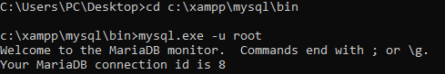

**Step 2: Create database:**



**Step 3: Using database:**



**Step 4: Create table and description of table:**

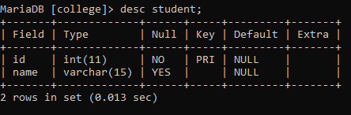

**Step 5: Inserting records into table:**



**Step 6: Using Select Command, displaying the entire records of the table:**

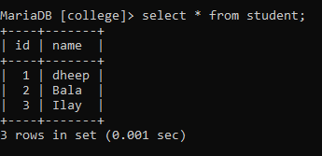

**Step 7: Create User:**

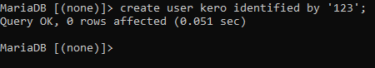

**Step 8: Command to see the total number of users created:**

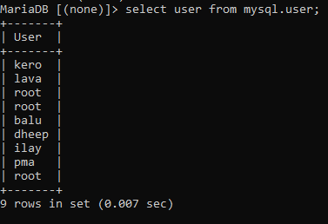

**Step 9: GRANT Permission to access the table with SELECT, INSERT AND UPDATE command:**



**Step 10: Exit out from root:**



**Step 1: Now enter into newly created User:**

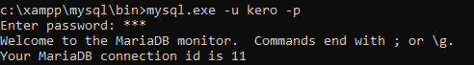

**Step 2: Use the database for inserting, updating and selecting the tables:**

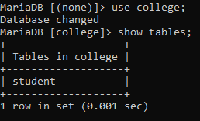

**Step 3: Check for the permission of the tables (INSERT, UPDATE, SELECT):**

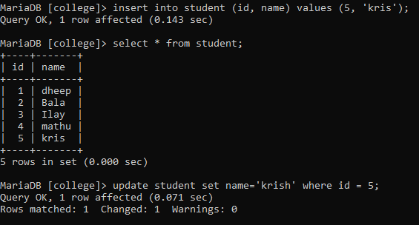

**Step 4: Other Commands like DELETE, ALTER etc will not work, because the GRANT permission is not allowed these commands:**



**Step 5: Exit out from root:**

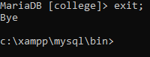

**Step 1: Again Log into root to REVOKE the permissions:**



**Step 2: Use the database to REVOKE permission:**

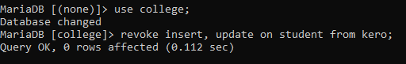

**Step 3: Exit from root and Log into user to check for permissions:**

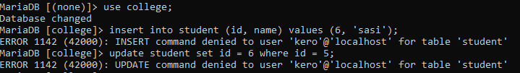

**Step 1: Only the select will work, because its Grant is not revoked:**

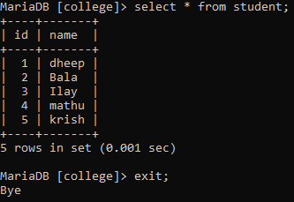

**Results:**

Hence the Data Control Language commands are successfully executed.